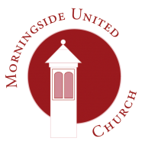 | Morningside United Church  15 Chamberlain Road  Edinburgh  EH10 4DJ  Scottish Charity Number - SC015552
Name
Address
Consent form 1
The church would like your permission to store your email address and phone number. If you are willing, please provide the details below:

Telephone number
email address

We would like to use your personal data in the following ways. You are free to choose any or all of the following options. Consent will be reviewed periodically.
Publication | Data | Consent given  | Consent refused 
Order of service | Name
 | Telephone number
 | email address
“The Link” magazine | Name
 | Telephone number
 | email address
 | A personal picture
MUC website | Name
 | Telephone number
 | email address
 | A personal picture
Other church publications within or beyond MUC | Name
 | A personal picture

Written or verbal consent? __________________
Signed: | Date:

You can withdraw your consent in part or in full at any time by contacting the Data Protection Officer at the Church’s address above. You can find our privacy notice at www.morningsideunitedchurch.org.uk A printed version is available on request.
churchoffice.muc@gmail.com
Morningside United Church is a registered Scottish Charity SCO15552

