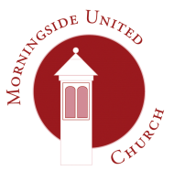 | Morningside United Church  15 Chamberlain Road  Edinburgh  EH10 4DJ  Scottish Charity Number - SC015552
Consent form 2
The church would like your permission to use your personal data in the following ways. You are free to choose any or all of the following options. Consent will be reviewed periodically.
 | photos |  |  | voice recordings |  | videos
 | MUC’s  “The Link” magazine or other church publications | Internet eg church website | publicity | parents only | internet (eg church website, YouTube*) | parents only | internet (eg church website, YouTube*)
those which apply
t
* YouTube comments would always be disabled
No personal information, such as the children’s names and schools, will be shared with the photos.
Please provide the information below so that we can contact you about activities relating to the choir and in the case of an emergency.

Form continues overleaf.

Full name of child
Health / allergy information where applicable
Parent/Guardian: | First name
 | Telephone number
 | email address

Signed: | Date:

You can withdraw your consent in part or in full at any time by contacting the Data Protection Officer at the Church’s address above. You can find our privacy notice at www.morningsideunitedchurch.org.uk A printed version is available on request.

churchoffice.muc@gmail.com
Morningside United Church is a registered Scottish Charity SCO15552

