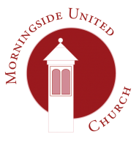 | Morningside United Church  15 Chamberlain Road  Edinburgh  EH10 4DJ  Scottish Charity Number - SC015552
Consent form 3
The church would like your permission to use your personal data in the following ways. Consent will be reviewed periodically.
Reason | Data | Consent given 
Over 90’s birthday card | Name
 | Address
 | Date of birth:-

Written or verbal consent? __________________
Name
Address
Date of birth

Signed: | Date:

You can withdraw your consent in part or in full at any time by contacting the Data Protection Officer at the Church’s address above. You can find our privacy notice at www.morningsideunitedchurch.org.uk A printed version is available on request.

churchoffice.muc@gmail.com
Morningside United Church is a registered Scottish Charity SCO15552

