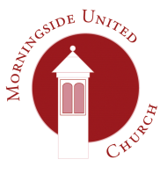 | Morningside United Church  15 Chamberlain Road  Edinburgh  EH10 4DJ  Scottish Charity Number - SC015552
Consent form 4
The church would like your permission to add the name of your baby or child to our cradle roll. The cradle roll is on public display within the church buildings. Please complete this form if you wish to give your consent.
Name of baby or child
Date of baptism

Written or verbal consent? __________________
Name
Address

Signed: | Date:

You can withdraw your consent in part or in full at any time by contacting the Data Protection Officer at the Church’s address above. You can find our privacy notice at www.morningsideunitedchurch.org.uk A printed version is available on request.

churchoffice.muc@gmail.com
Morningside United Church is a registered Scottish Charity SCO15552

